**Week - 5**

**(20 July 2023)**

**Experiment - 5**

**Question:**

1. Write a C program to simulate Real-Time CPU Scheduling algorithms:

**a)** Rate- Monotonic

**b)** Earliest-deadline First

**c)** Proportional scheduling

1. Write a C program to simulate producer-consumer problem using semaphores.
2. Write a C program to simulate the concept of Dining-Philosophers problem.

**Program:**

1. **CPU Scheduling:**

#include <stdio.h>

#include <stdlib.h>

#include <math.h>

#include <stdbool.h>

#define MAX_PROCESS 10

typedef struct {

int id;

int burst_time;

float priority;

} Task;

int num_of_process;

int execution_time[MAX_PROCESS], period[MAX_PROCESS], remain_time[MAX_PROCESS], deadline[MAX_PROCESS], remain_deadline[MAX_PROCESS];

void get_process_info(int selected_algo)

{

printf("Enter total number of processes (maximum %d): ", MAX_PROCESS);

scanf("%d", &num_of_process);

if (num_of_process < 1)

{

exit(0);

}

for (int i = 0; i < num_of_process; i++)

{

printf("\nProcess %d:\n", i + 1);

printf("==> Execution time: ");

scanf("%d", &execution_time[i]);

remain_time[i] = execution_time[i];

if (selected_algo == 2)

{

printf("==> Deadline: ");

scanf("%d", &deadline[i]);

}

else

{

printf("==> Period: ");

scanf("%d", &period[i]);

}

}

}

int max(int a, int b, int c)

{

int max;

if (a >= b && a >= c)

max = a;

else if (b >= a && b >= c)

max = b;

else if (c >= a && c >= b)

max = c;

return max;

}

int get_observation_time(int selected_algo)

{

if (selected_algo == 1)

{

return max(period[0], period[1], period[2]);

}

else if (selected_algo == 2)

{

return max(deadline[0], deadline[1], deadline[2]);

}

}

void print_schedule(int process_list[], int cycles)

{

printf("\nScheduling:\n\n");

printf("Time: ");

for (int i = 0; i < cycles; i++)

{

if (i < 10)

printf("| 0%d ", i);

else

printf("| %d ", i);

}

printf("|\n");

for (int i = 0; i < num_of_process; i++)

{

printf("P[%d]: ", i + 1);

for (int j = 0; j < cycles; j++)

{

if (process_list[j] == i + 1)

printf("|####");

else

printf("| ");

}

printf("|\n");

}

}

void rate_monotonic(int time)

{

int process_list[100] = {0}, min = 999, next_process = 0;

float utilization = 0;

for (int i = 0; i < num_of_process; i++)

{

utilization += (1.0 * execution_time[i]) / period[i];

}

int n = num_of_process;

int m = (float) (n * (pow(2, 1.0 / n) - 1));

if (utilization > m)

{

printf("\nGiven problem is not schedulable under the said scheduling algorithm.\n");

}

for (int i = 0; i < time; i++)

{

min = 1000;

for (int j = 0; j < num_of_process; j++)

{

if (remain_time[j] > 0)

{

if (min > period[j])

{

min = period[j];

next_process = j;

}

}

}

if (remain_time[next_process] > 0)

{

process_list[i] = next_process + 1;

remain_time[next_process] -= 1;

}

for (int k = 0; k < num_of_process; k++)

{

if ((i + 1) % period[k] == 0)

{

remain_time[k] = execution_time[k];

next_process = k;

}

}

}

print_schedule(process_list, time);

}

void earliest_deadline_first(int time){

float utilization = 0;

for (int i = 0; i < num_of_process; i++){

utilization += (1.0*execution_time[i])/deadline[i];

}

int n = num_of_process;

int process[num_of_process];

int max_deadline, current_process=0, min_deadline,process_list[time];

bool is_ready[num_of_process];

for(int i=0; i<num_of_process; i++){

is_ready[i] = true;

process[i] = i+1;

}

max_deadline=deadline[0];

for(int i=1; i<num_of_process; i++){

if(deadline[i] > max_deadline)

max_deadline = deadline[i];

}

for(int i=0; i<num_of_process; i++){

for(int j=i+1; j<num_of_process; j++){

if(deadline[j] < deadline[i]){

int temp = execution_time[j];

execution_time[j] = execution_time[i];

execution_time[i] = temp;

temp = deadline[j];

deadline[j] = deadline[i];

deadline[i] = temp;

temp = process[j];

process[j] = process[i];

process[i] = temp;

}

}

}

for(int i=0; i<num_of_process; i++){

remain_time[i] = execution_time[i];

remain_deadline[i] = deadline[i];

}

for (int t = 0; t < time; t++){

if(current_process != -1){

--execution_time[current_process];

process_list[t] = process[current_process];

}

else

process_list[t] = 0;

for(int i=0;i<num_of_process;i++){

--deadline[i];

if((execution_time[i] == 0) && is_ready[i]){

deadline[i] += remain_deadline[i];

is_ready[i] = false;

}

if((deadline[i] <= remain_deadline[i]) && (is_ready[i] == false)){

execution_time[i] = remain_time[i];

is_ready[i] = true;

}

}

min_deadline = max_deadline;

current_process = -1;

for(int i=0;i<num_of_process;i++){

if((deadline[i] <= min_deadline) && (execution_time[i] > 0)){

current_process = i;

min_deadline = deadline[i];

}

}

}

print_schedule(process_list, time);

}

void proportionalScheduling() {

int n;

printf("Enter the number of tasks: ");

scanf("%d", &n);

Task tasks[n];

printf("Enter burst time and priority for each task:\n");

for (int i = 0; i < n; i++) {

tasks[i].id = i + 1;

printf("Task %d - Burst Time: ", tasks[i].id);

scanf("%d", &tasks[i].burst_time);

printf("Task %d - Priority: ", tasks[i].id);

scanf("%f", &tasks[i].priority);

}

// Sort tasks based on priority (ascending order)

for (int i = 0; i < n - 1; i++) {

for (int j = 0; j < n - i - 1; j++) {

if (tasks[j].priority > tasks[j + 1].priority) {

// Swap tasks

Task temp = tasks[j];

tasks[j] = tasks[j + 1];

tasks[j + 1] = temp;

}

}

}

printf("\nProportional Scheduling:\n");

int total_burst_time = 0;

float total_priority = 0.0;

for (int i = 0; i < n; i++) {

total_burst_time += tasks[i].burst_time;

total_priority += tasks[i].priority;

}

for (int i = 0; i < n; i++) {

float time_slice = (tasks[i].priority / total_priority) * total_burst_time;

printf("Task %d executes for %.2f units of time\n", tasks[i].id, time_slice);

}

}

int main()

{

int option;

int observation_time;

while (1)

{

printf("\n1. Rate Monotonic\n2. Earliest Deadline first\n3. Proportional Scheduling\n\nEnter your choice: ");

scanf("%d", &option);

switch(option)

{

case 1: get_process_info(option);

observation_time = get_observation_time(option);

rate_monotonic(observation_time);

break;

case 2: get_process_info(option);

observation_time = get_observation_time(option);

earliest_deadline_first(observation_time);

break;

case 3: proportionalScheduling();

break;

case 4: exit (0);

default: printf("\nInvalid Statement");

}

}

return 0;

}

**Output: (CPU Scheduling)**

**Rate Monotonic:**

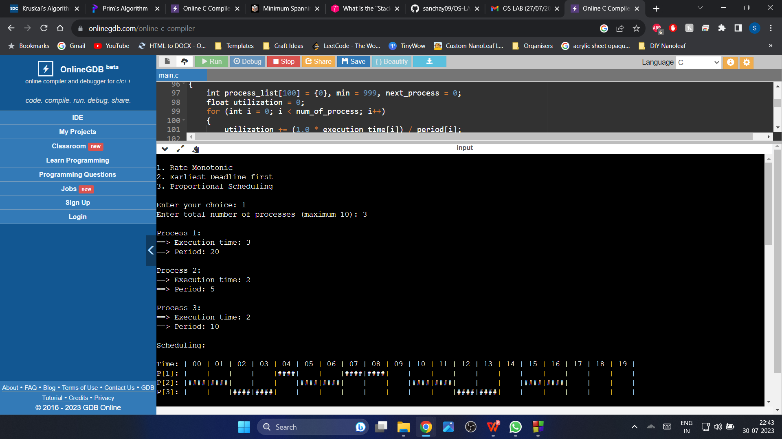

**Earliest Deadline First:**

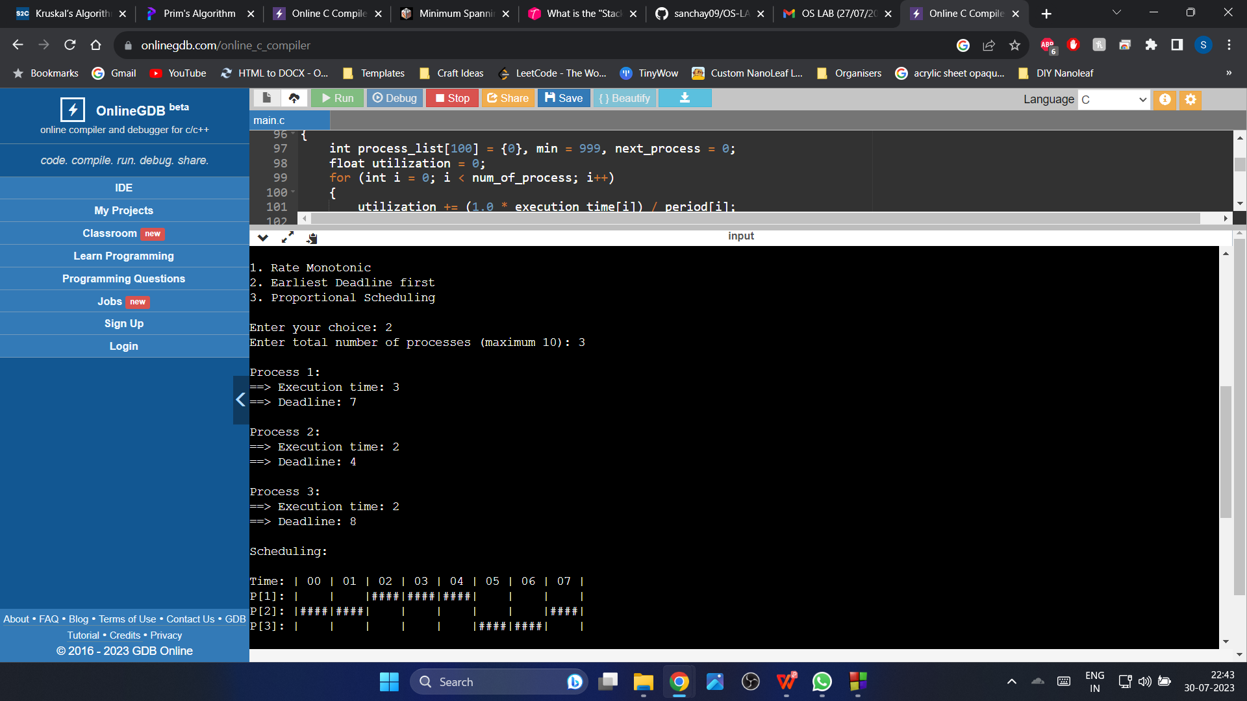

**Proportional Scheduling:**

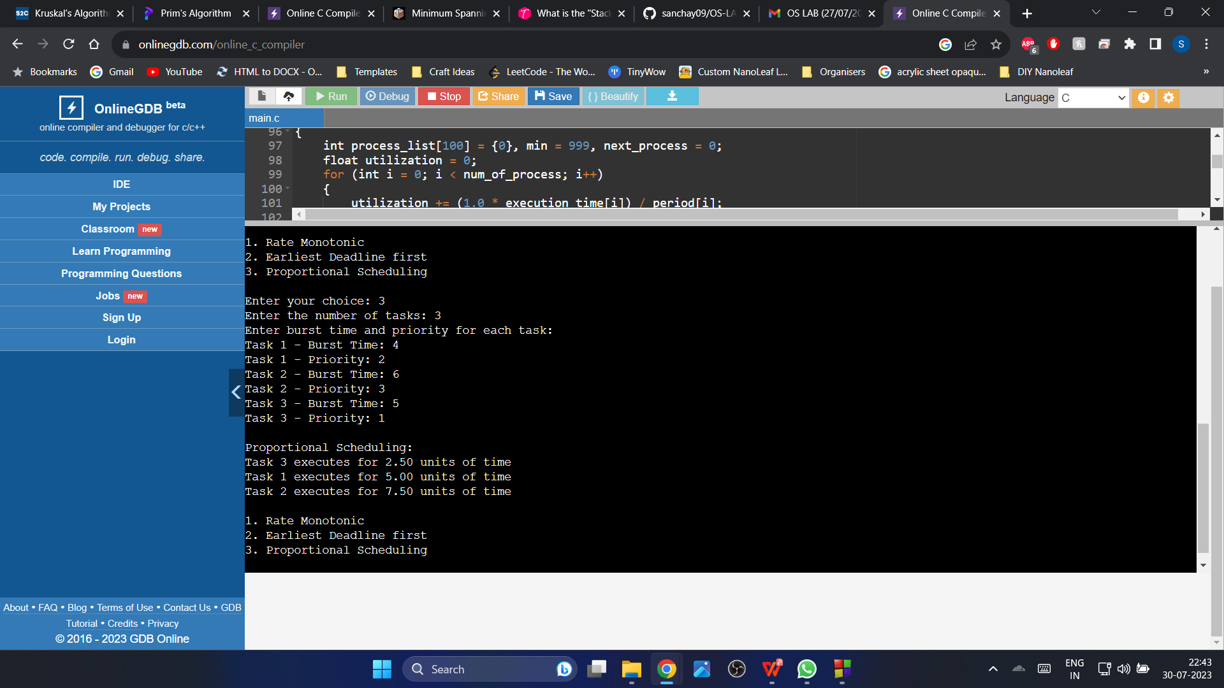

**Observation Book Pictures: (CPU Scheduling)**

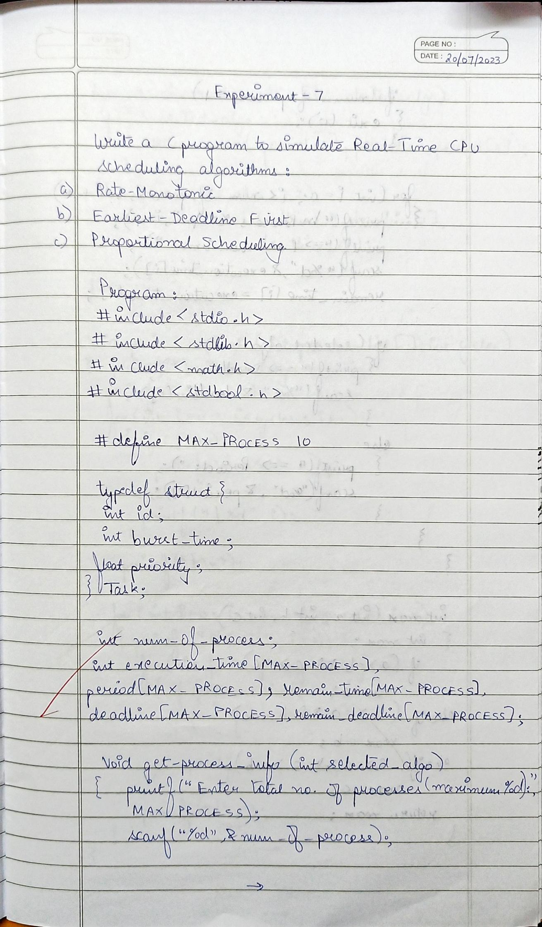

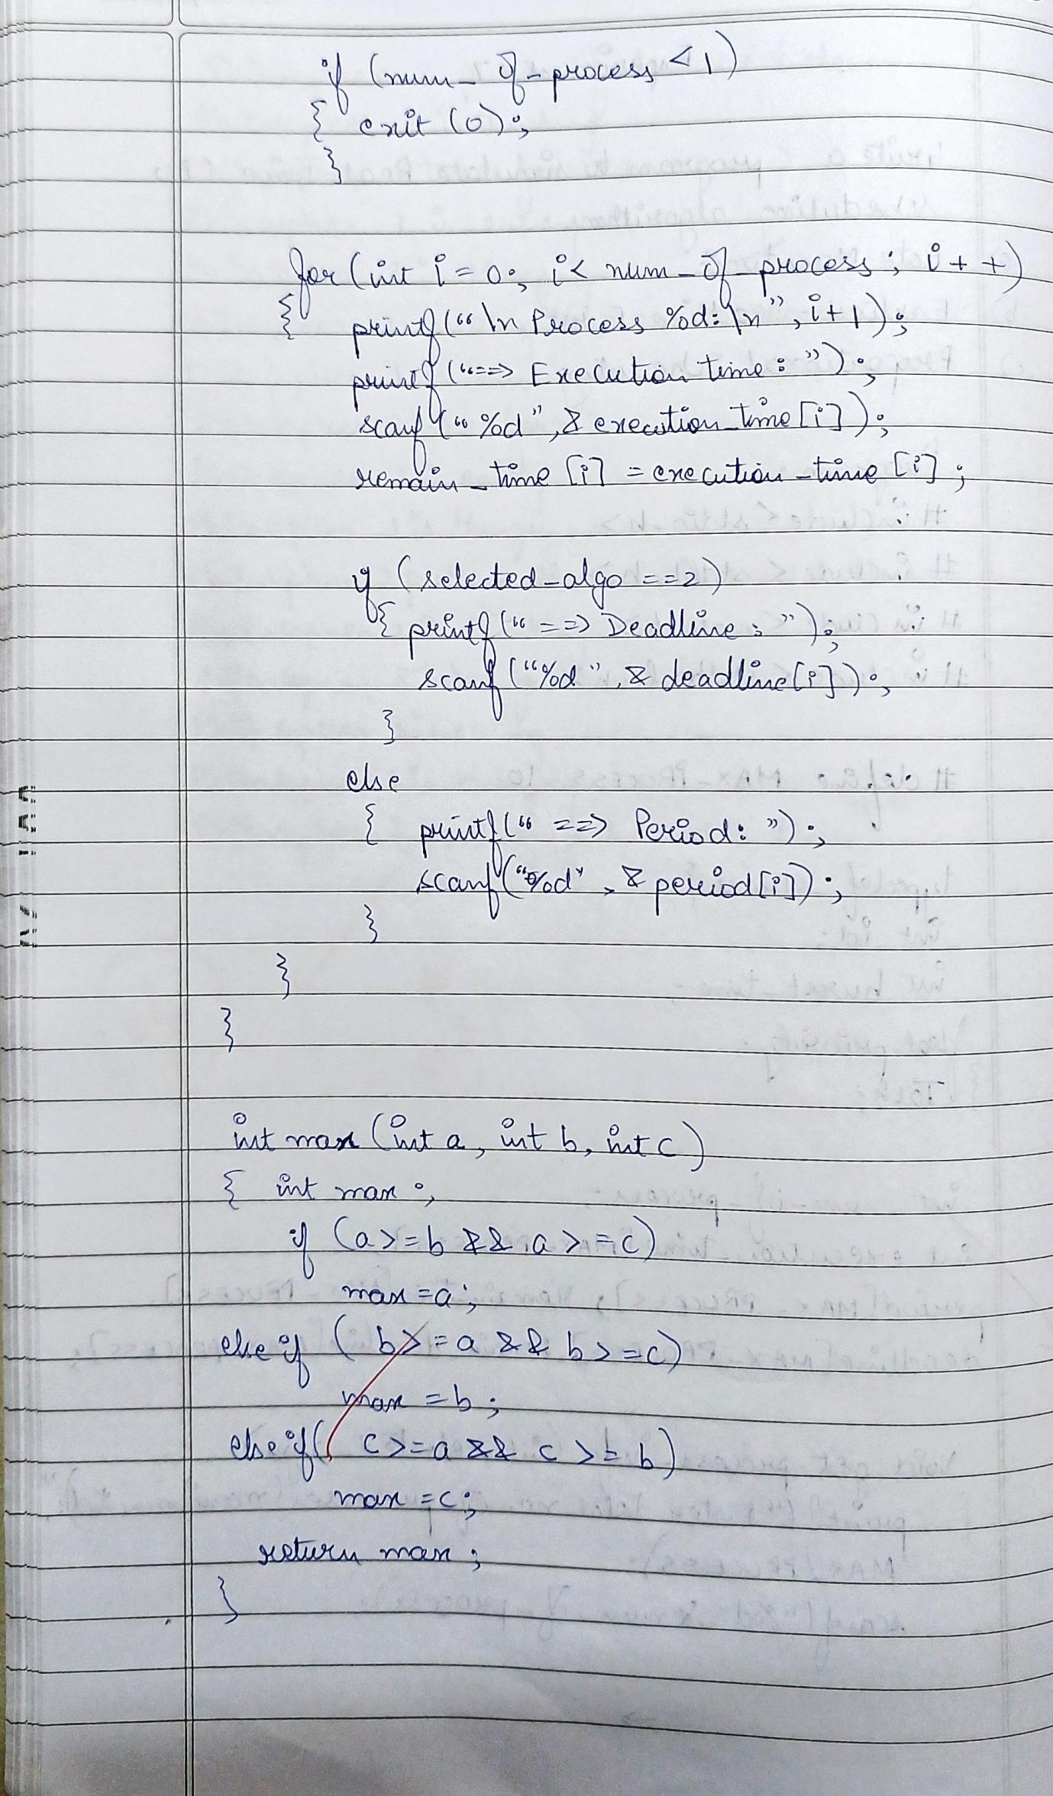

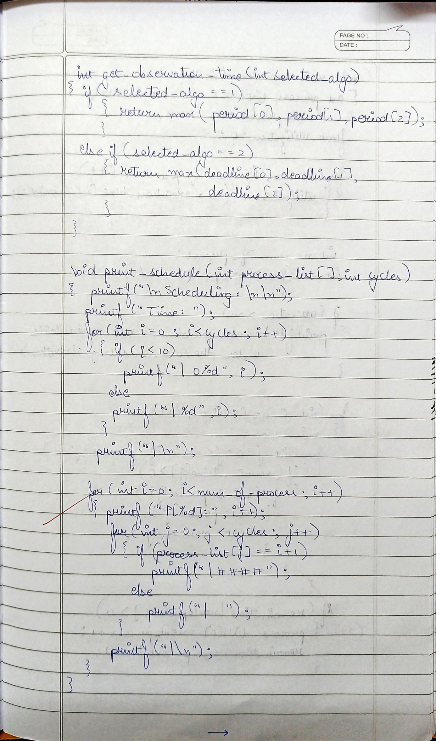

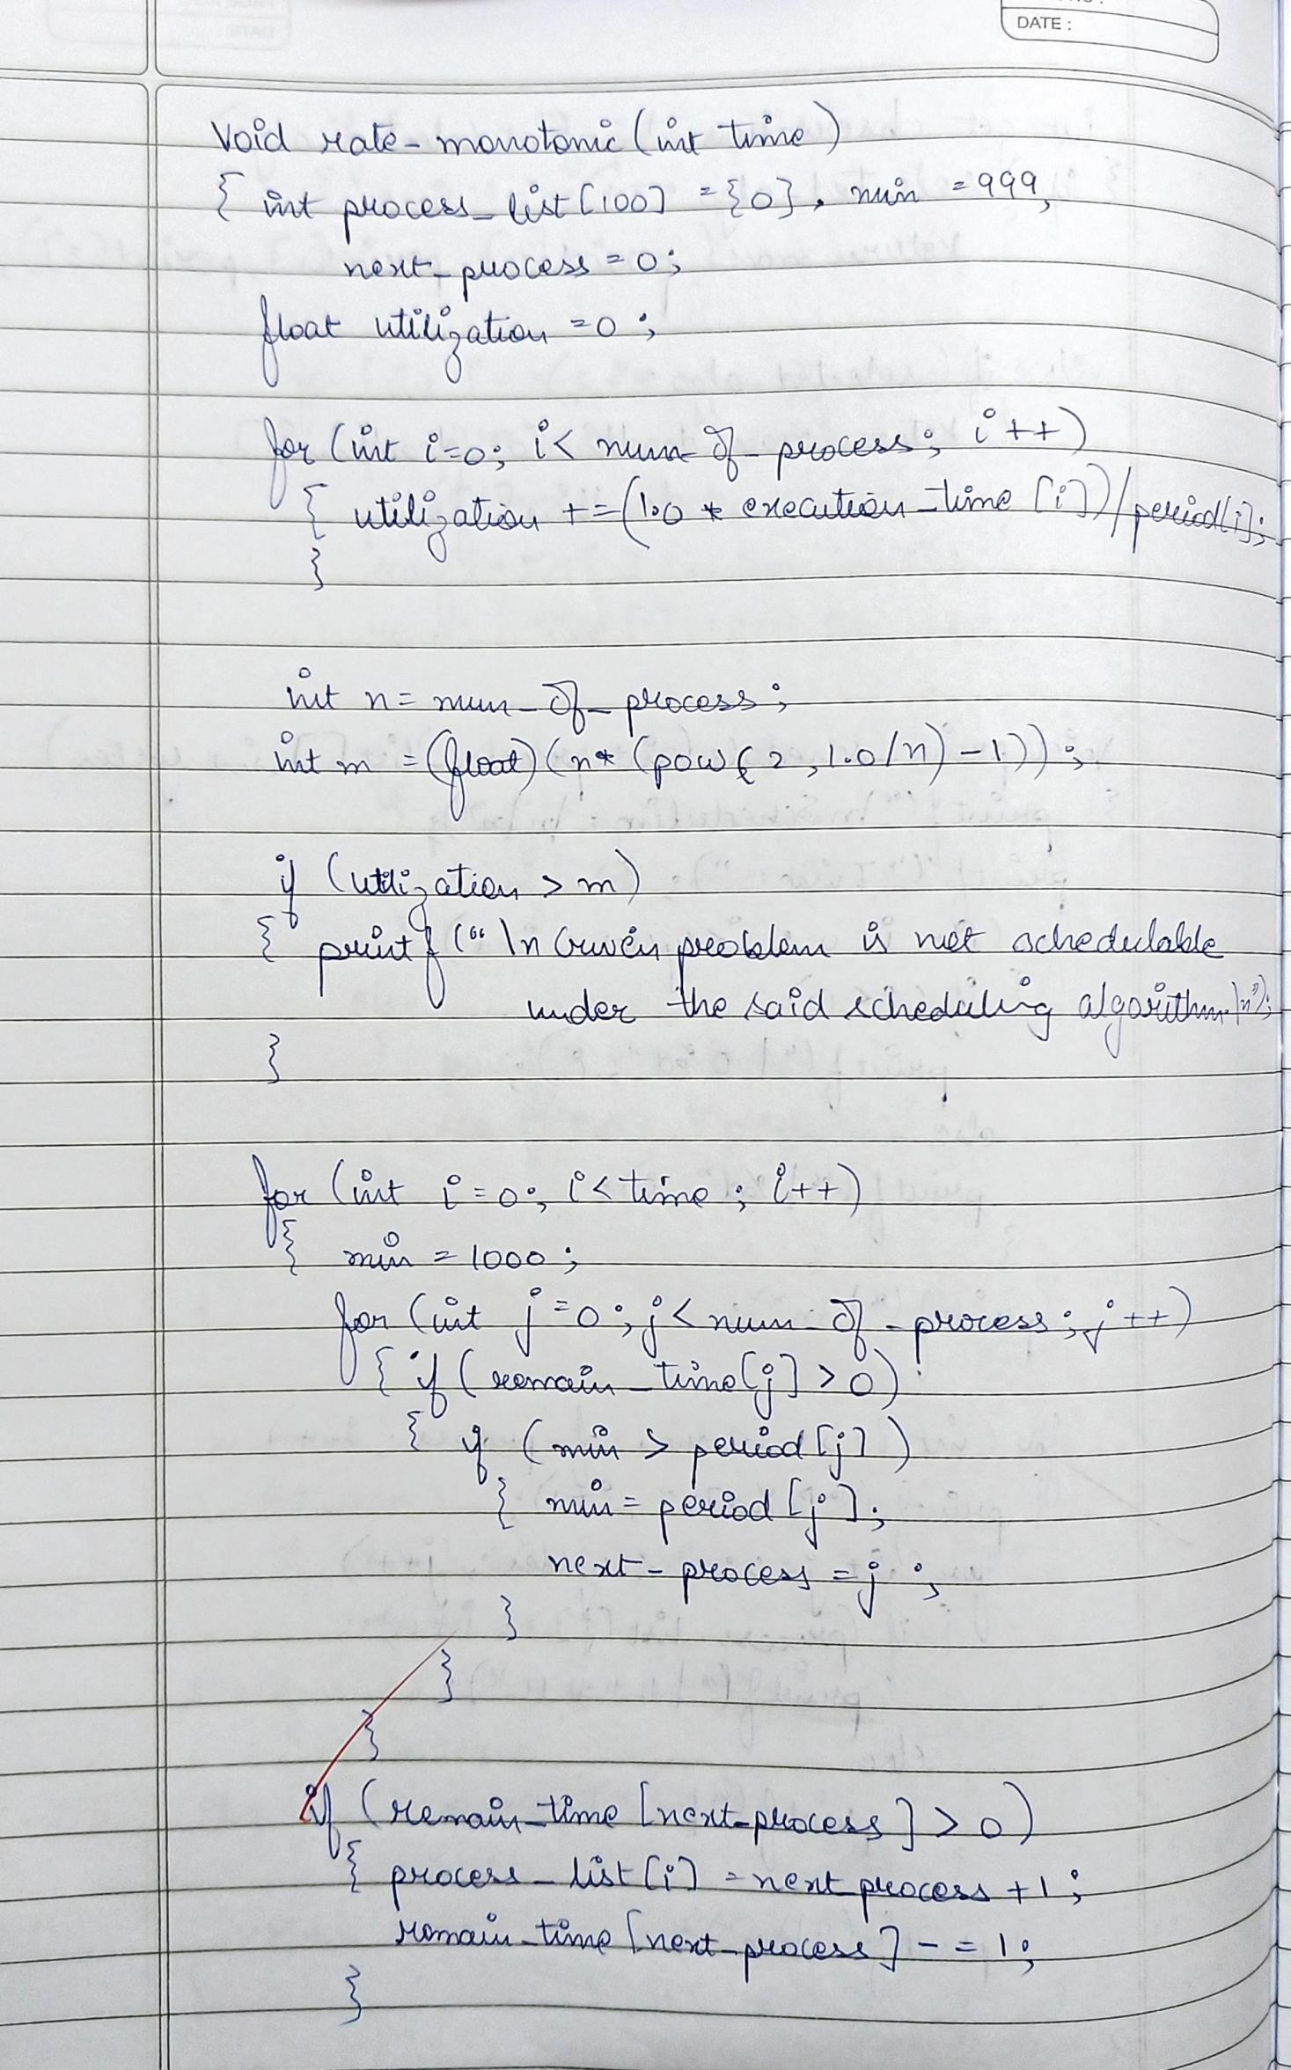

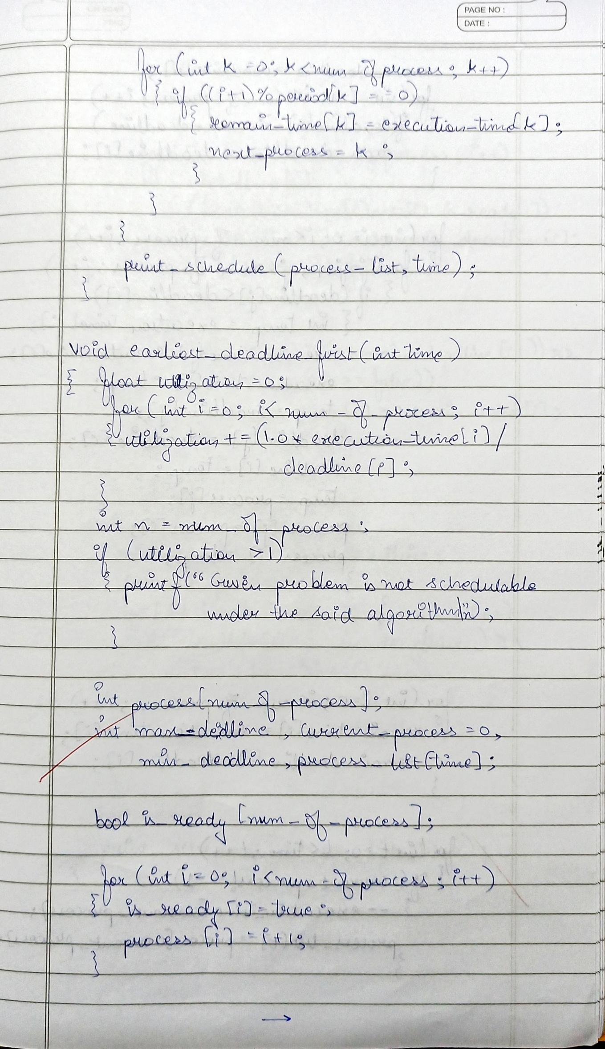

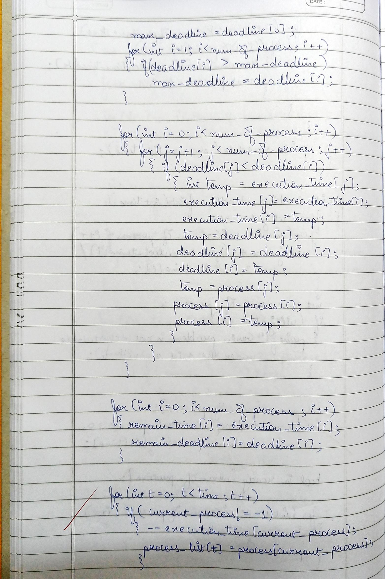

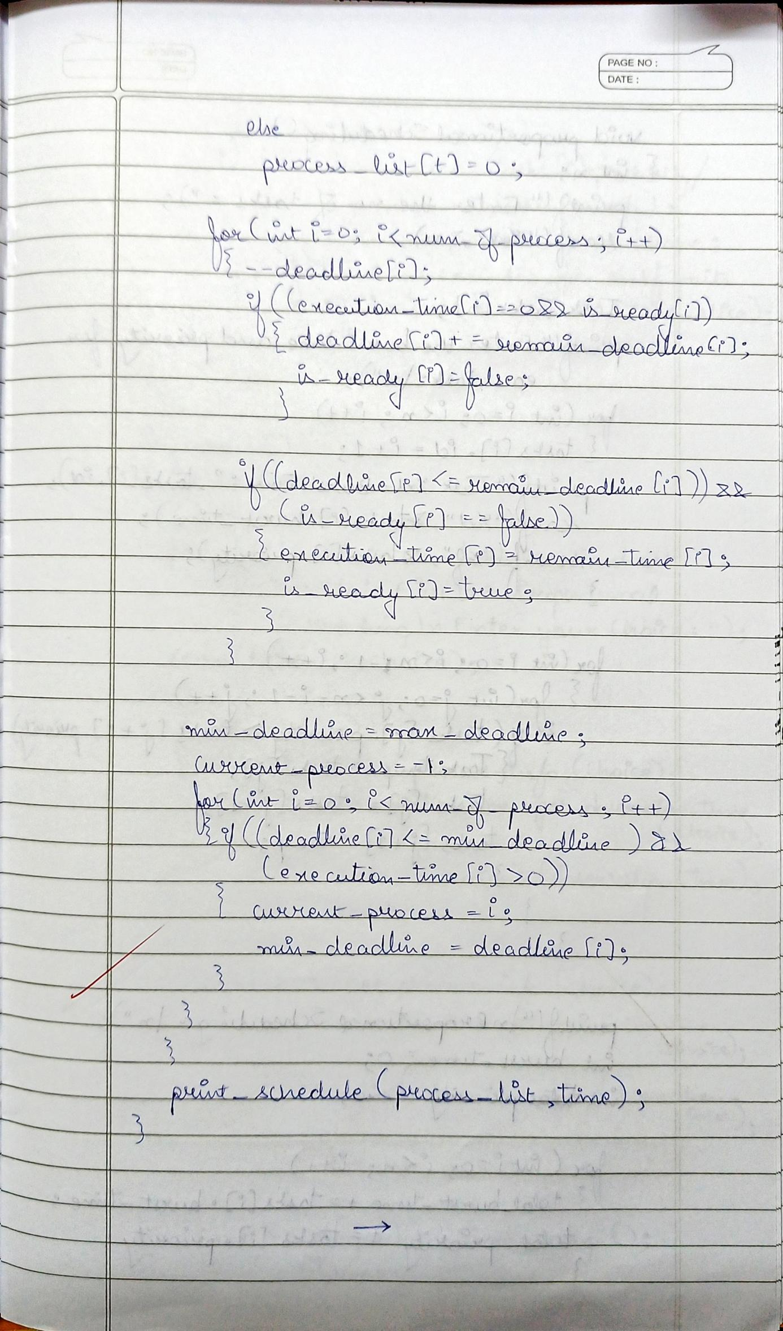

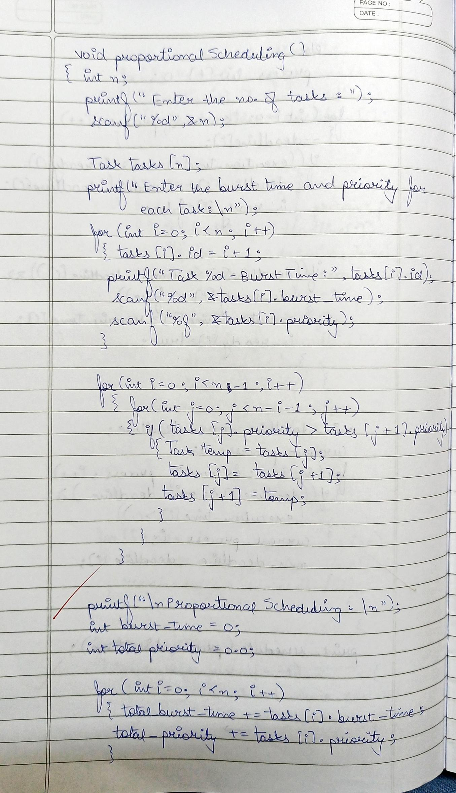

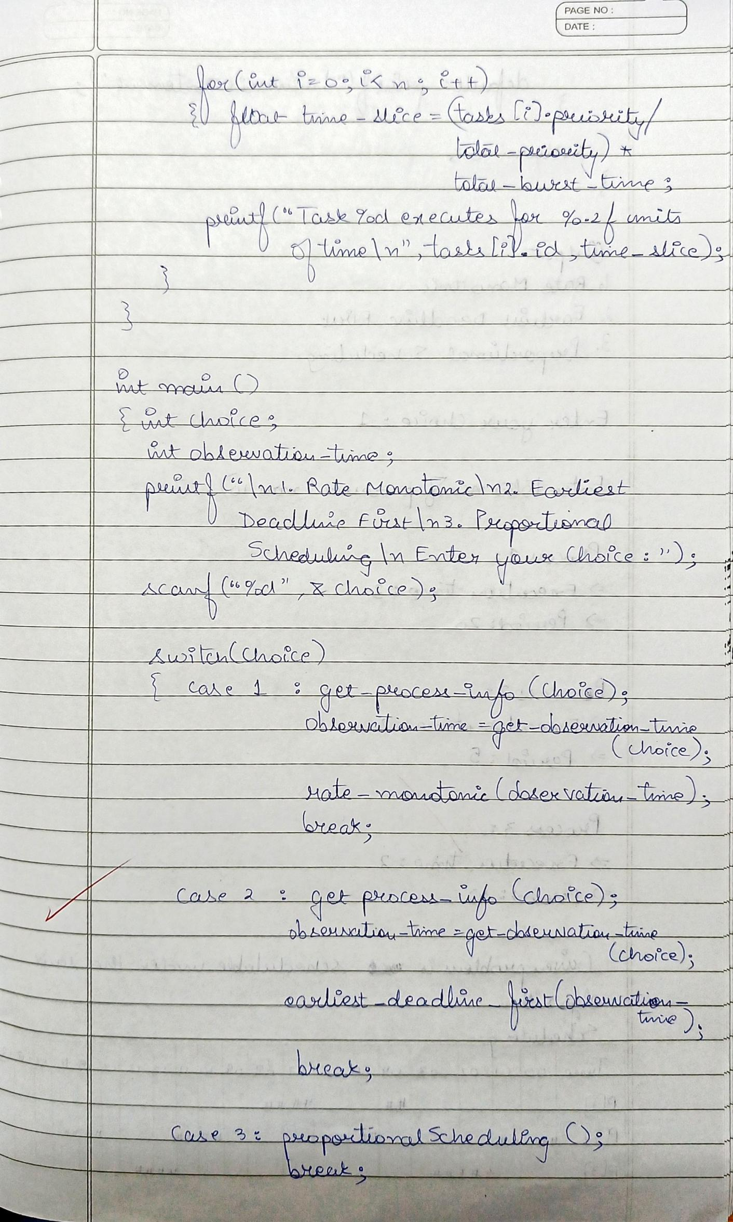

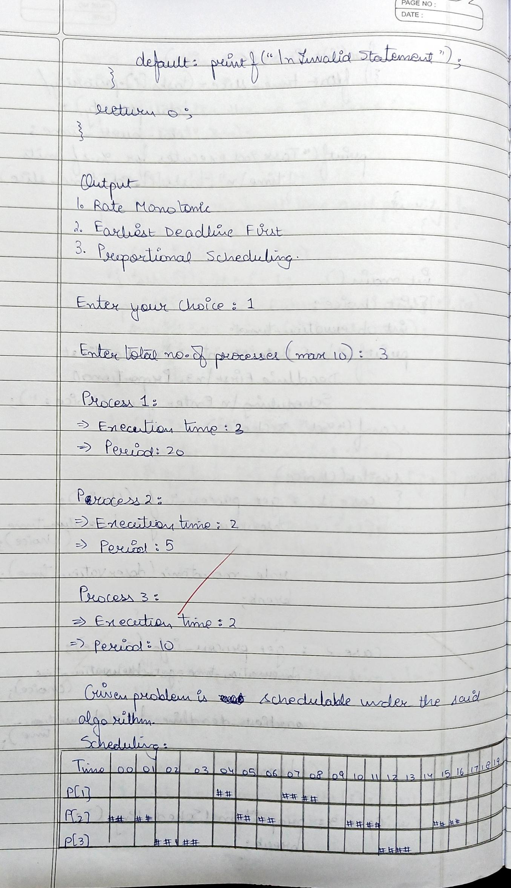

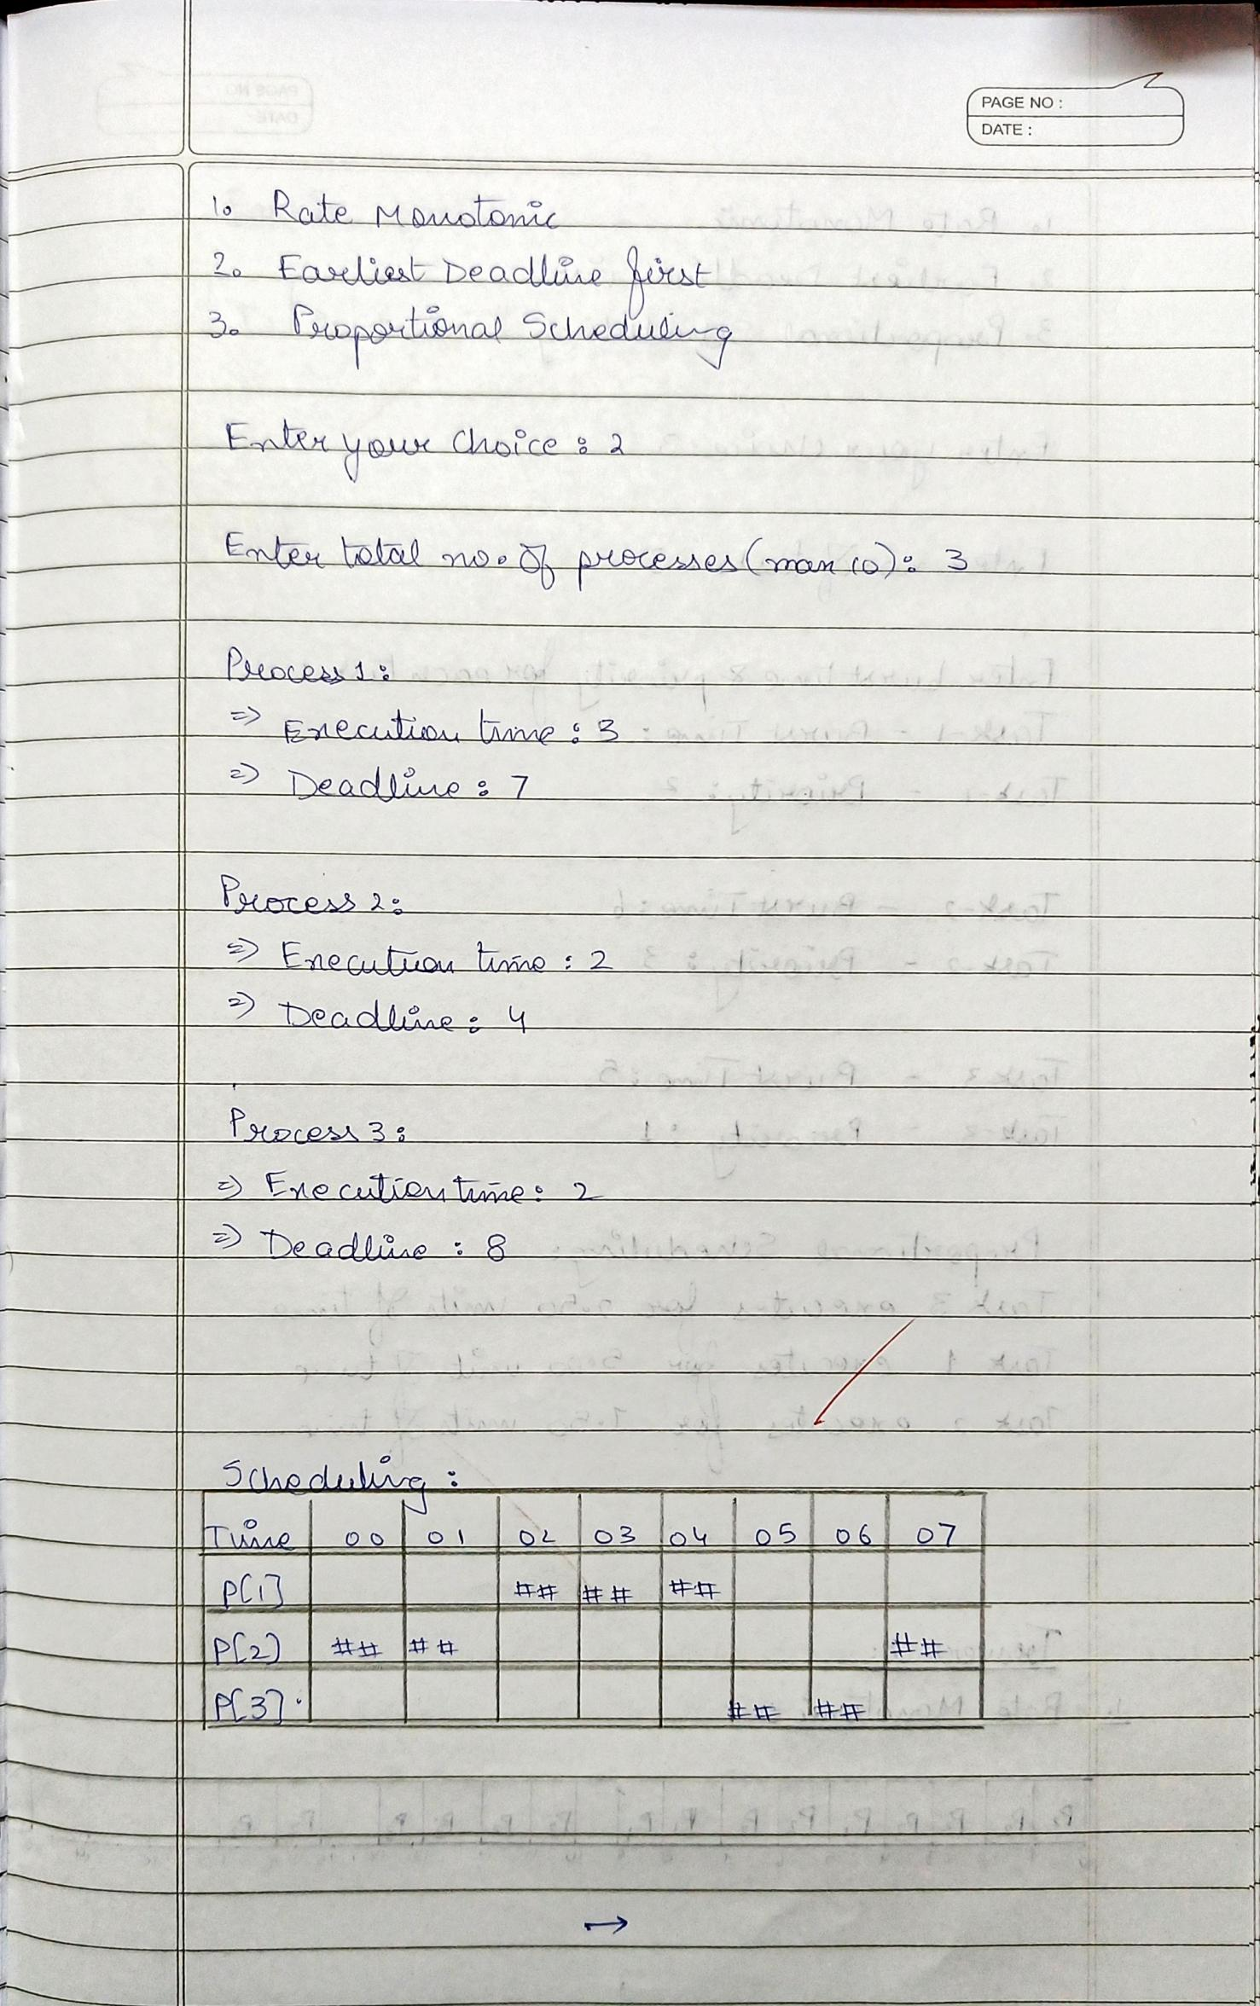

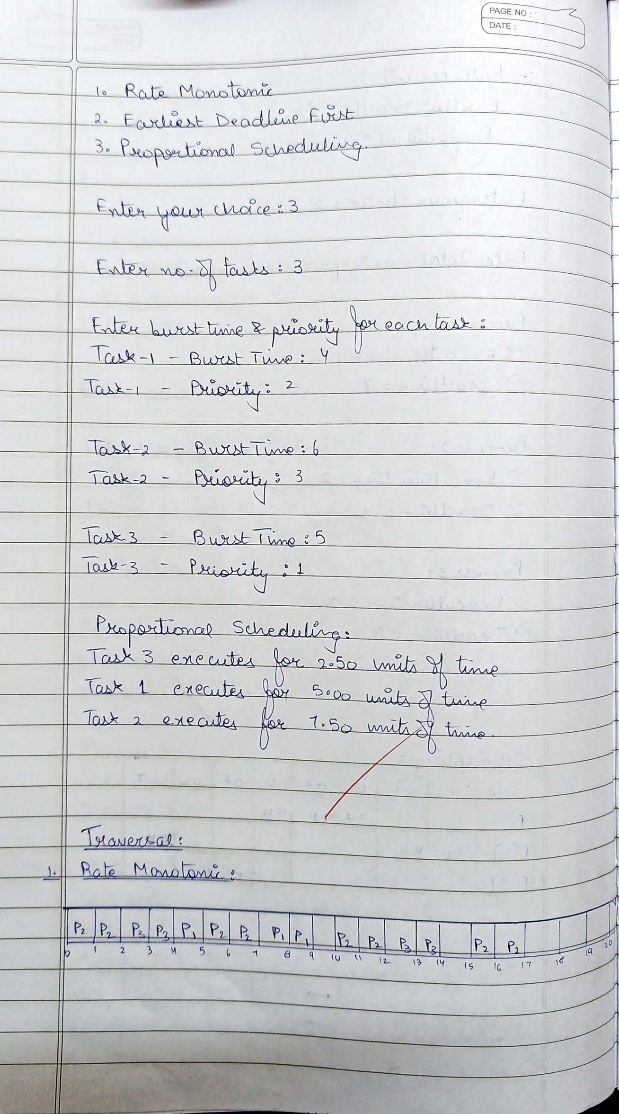

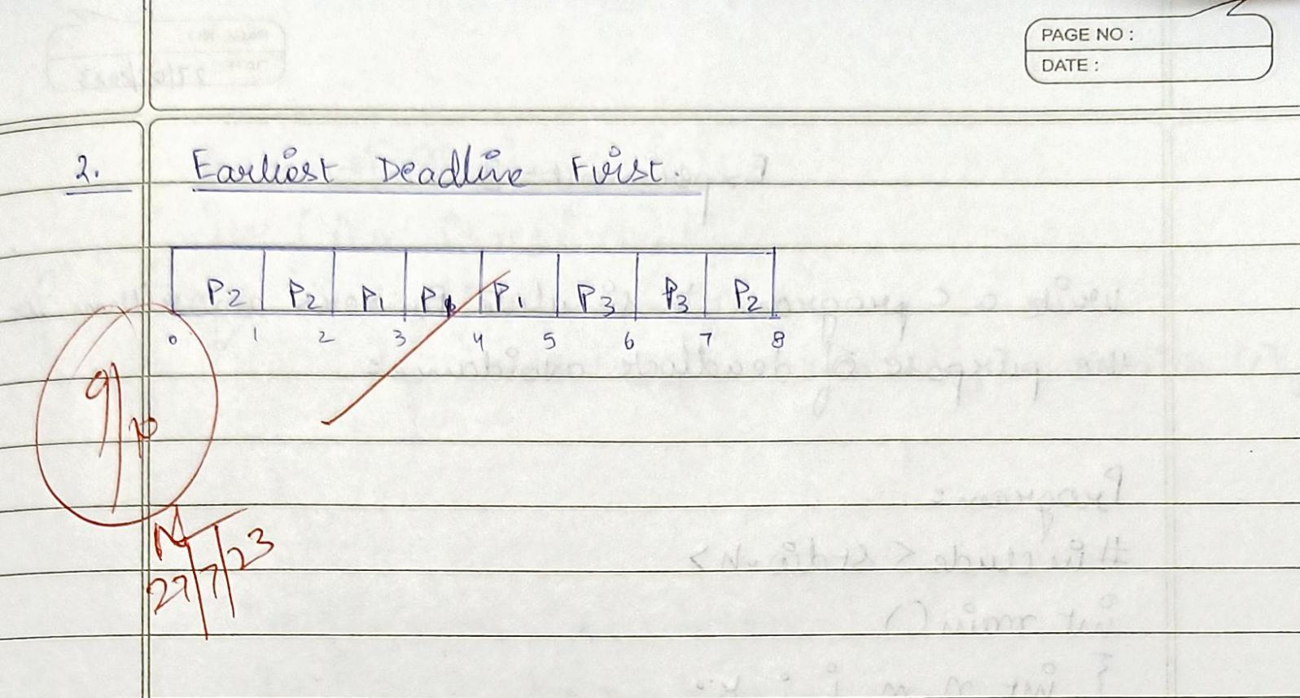

1. **Producer-Consumer Problem**

**Program:**

#include<stdio.h>

#include<stdlib.h>

int mutex=1,full=0,empty=3,x=0;

int main()

{

int n;

void producer();

void consumer();

int wait(int);

int signal(int);

printf("\n1.Producer\n2.Consumer\n3.Exit");

while(1)

{

printf("\nEnter your choice: ");

scanf("%d&",&n);

switch(n)

{

case 1: if((mutex==1)&&(empty!=0))

producer();

else

printf("Buffer is full!!");

break;

case 2: if((mutex==1)&&(full!=0))

consumer();

else

printf("Buffer is empty!!");

break;

case 3: exit(0);

break;

}

}

return 0;

}

int wait(int s)

{

return (--s);

}

int signal(int s)

{

return(++s);

}

void producer()

{

mutex=wait(mutex);

full=signal(full);

empty=wait(empty);

x++;

printf("\nProducer produces the item %d",x);

mutex=signal(mutex);

}

void consumer()

{

mutex=wait(mutex);

full=wait(full);

empty=signal(empty);

printf("\nConsumer consumes item %d",x);

x--;

mutex=signal(mutex);

}

**Output: (Producer - Consumer Problem)**

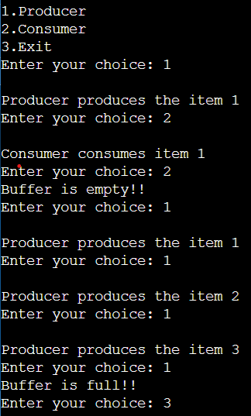

**Observation Book Pictures: (Producer - Consumer Problem)**

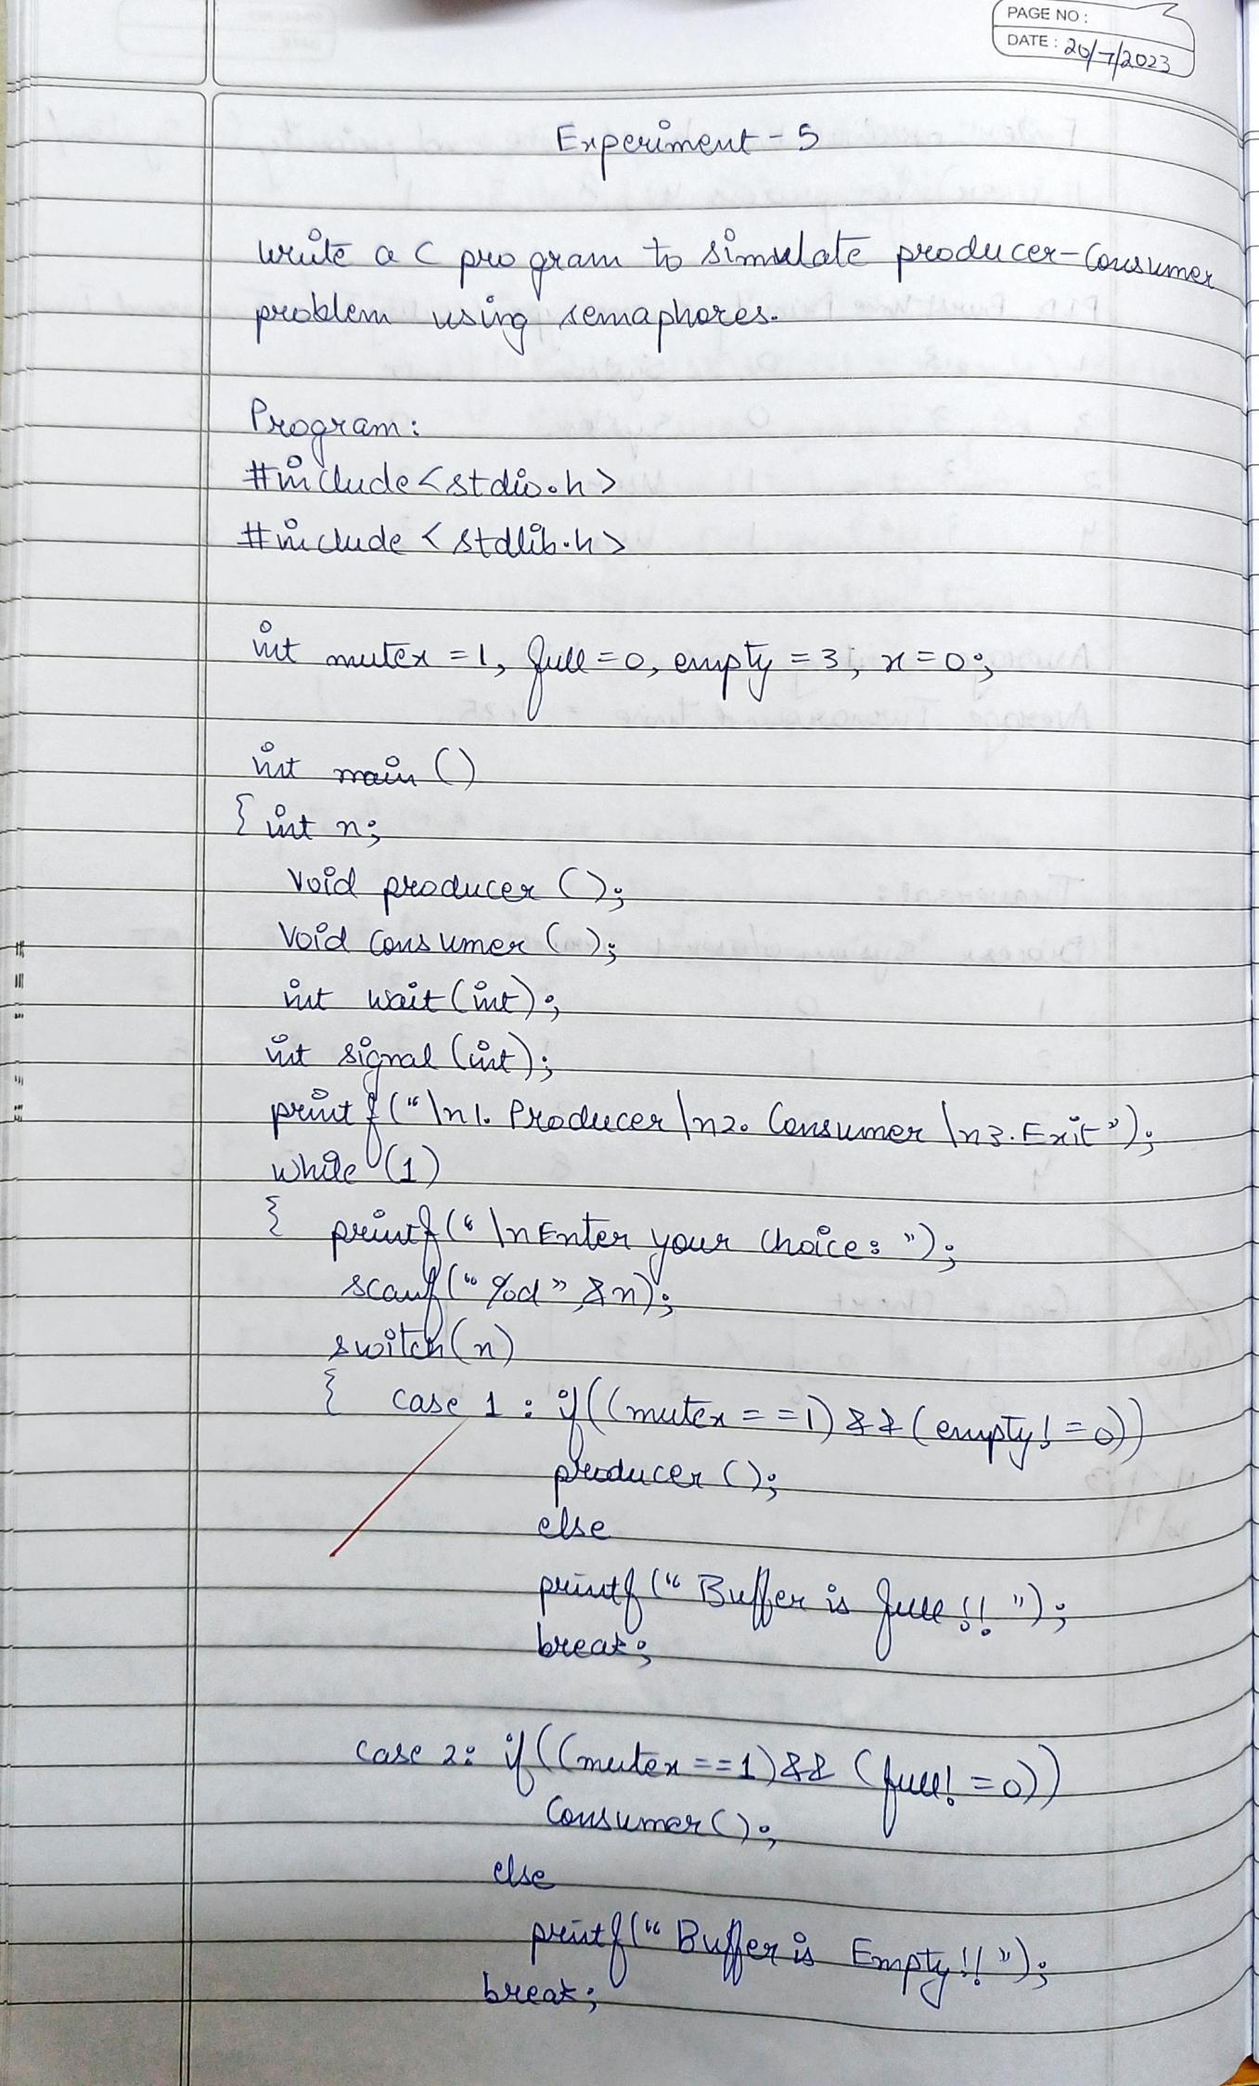

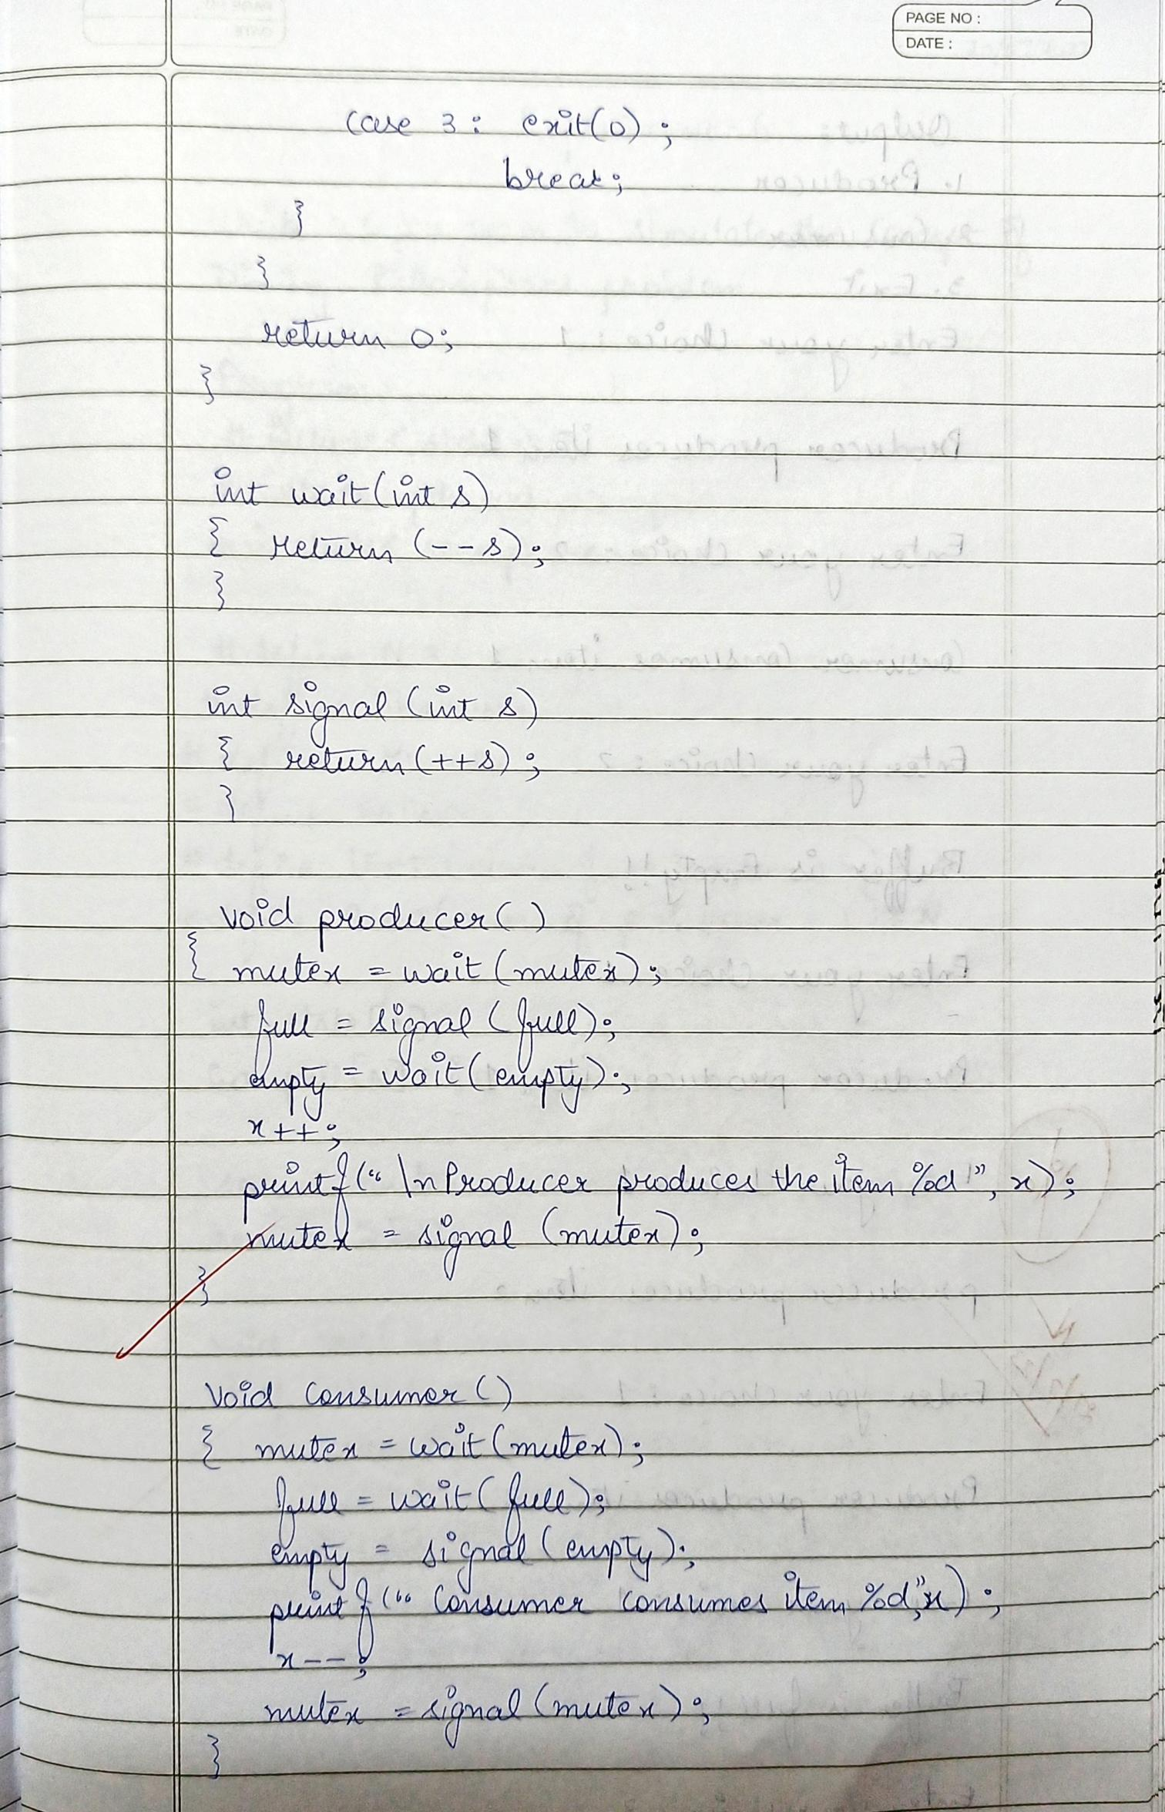

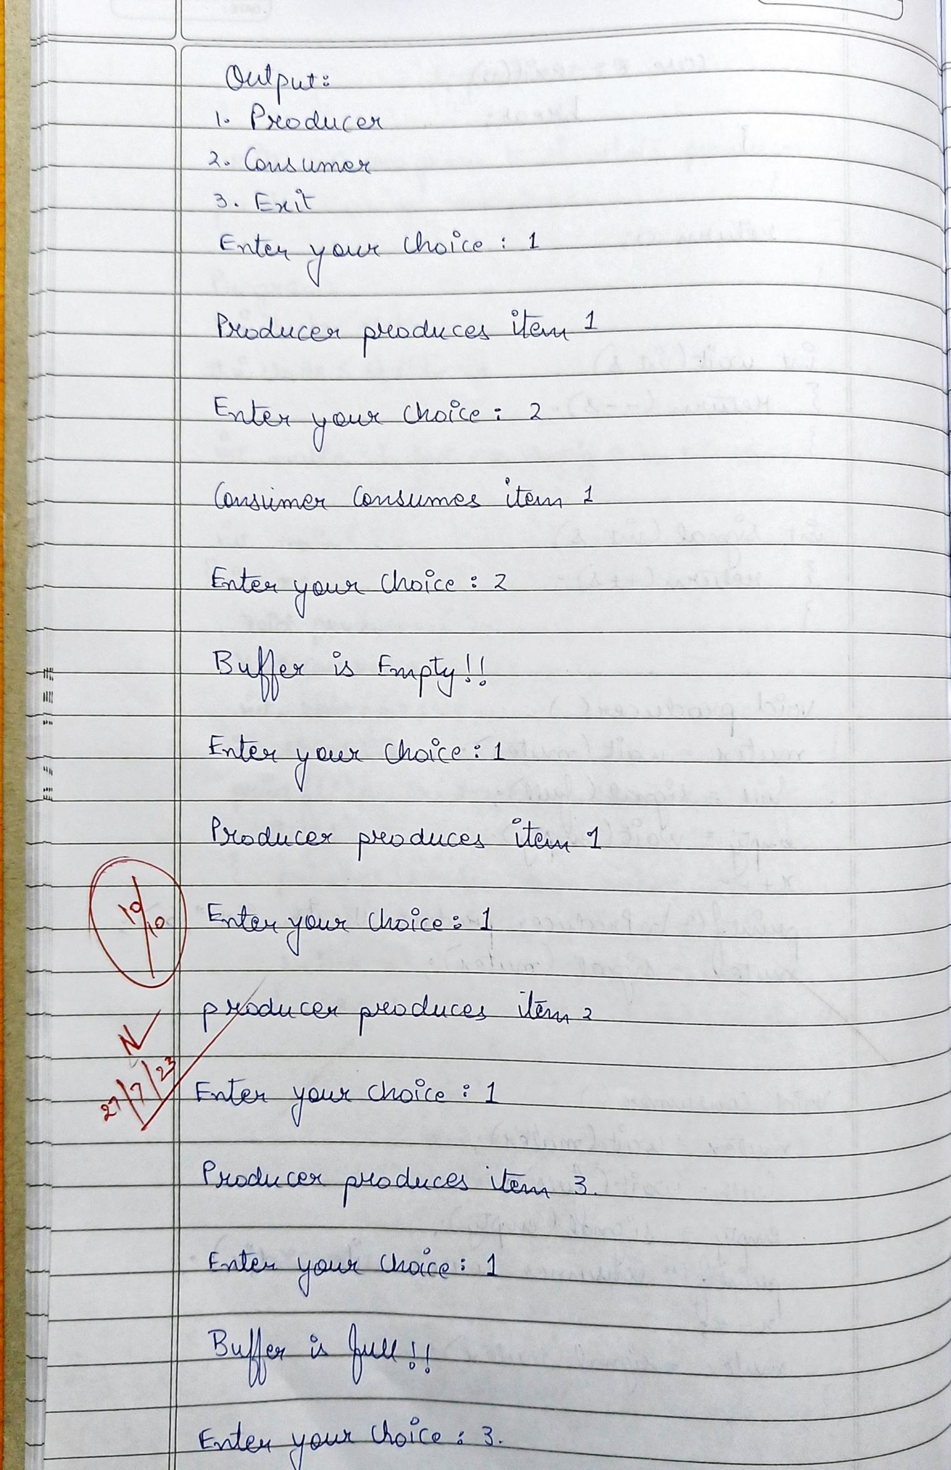

1. **Dining - Philosopher Problem:**

**Program:**

#include <stdio.h>

#include <pthread.h>

#include <semaphore.h>

#define N 5

#define THINKING 2

#define HUNGRY 1

#define EATING 0

#define LEFT (num_of_philosopher + 4) % N

#define RIGHT (num_of_philosopher + 1) % N

int state[N];

int phil[N] = {0,1,2,3,4};

sem_t mutex;

sem_t S[N];

void test(int num_of_philosopher)

{

if (state[num_of_philosopher] == HUNGRY && state[LEFT] != EATING && state[RIGHT] != EATING)

{

state[num_of_philosopher] = EATING;

sleep(2);

printf("Philosopher %d takes fork %d and %d\n", num_of_philosopher +1, LEFT +1, num_of_philosopher +1);

printf("Philosopher %d is Eating\n", num_of_philosopher +1);

sem_post(&S[num_of_philosopher]);

}

}

void take_fork(int num_of_philosopher)

{

sem_wait(&mutex);

state[num_of_philosopher] = HUNGRY;

printf("Philosopher %d is Hungry\n", num_of_philosopher +1);

test(num_of_philosopher);

sem_post(&mutex);

sem_wait(&S[num_of_philosopher]);

sleep(1);

}

void put_fork(int num_of_philosopher)

{

sem_wait(&mutex);

state[num_of_philosopher] = THINKING;

printf("Philosopher %d putting fork %d and %d down\n",num_of_philosopher +1, LEFT +1, num_of_philosopher +1);

printf("Philosopher %d is thinking\n", num_of_philosopher +1);

test(LEFT);

test(RIGHT);

sem_post(&mutex);

}

void* philosopher(void* num)

{

while (1)

{

int* i = num;

sleep(1);

take_fork(*i);

sleep(0);

put_fork(*i);

}

}

int main()

{

int i;

pthread_t thread_id[N];

sem_init(&mutex,0,1);

for (i =0; i < N; i++)

sem_init(&S[i],0,0);

for (i =0; i < N; i++) {

pthread_create(&thread_id[i],NULL,philosopher, &phil[i]);

printf("Philosopher %d is thinking\n", i +1);

}

for (i =0; i < N; i++)

{

pthread_join(thread_id[i],NULL);

}

}

**Output: (Dining - Philosopher Problem)**

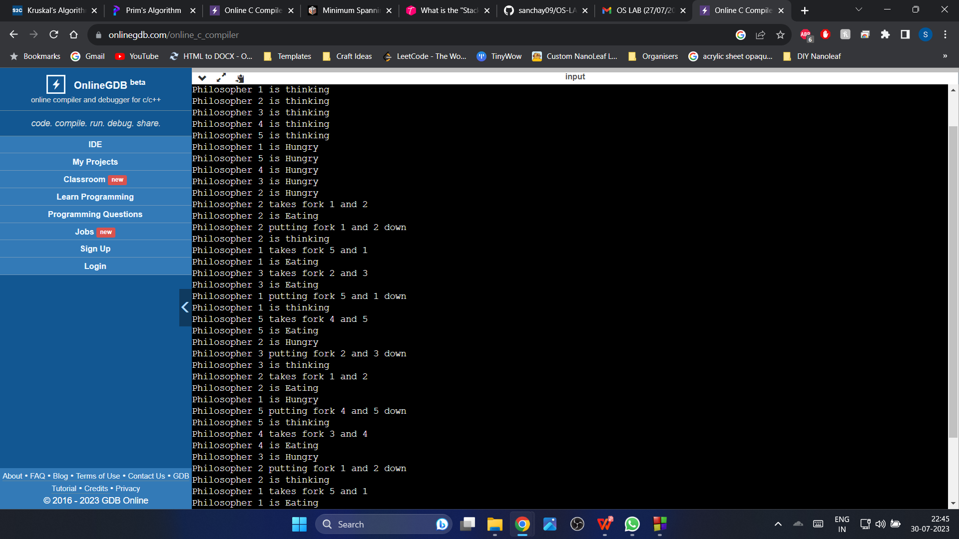

**Observation Book Pictures: (Dining - Philosopher Problem)**

